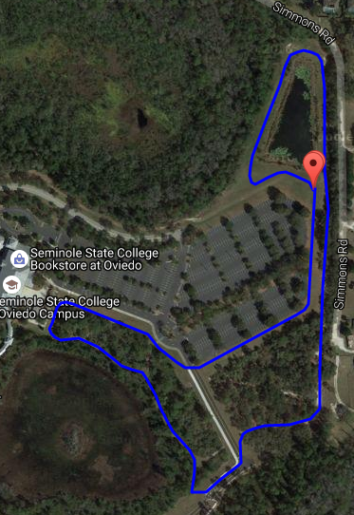

Team Camps

***Course Notes:***

1. Mile Loop – 95% Grass/Trail.

Crosses the Road on two segments.

Road is closed during the races.

Awards Ceremony on Hill/Swale near start line.

Awards

Finish

Start Line